# Testing and Debugging:

## Joshua Kovzan – 13243326 – 18/06/2024

### Passphrase function:

One of the first features I created and tested after receiving the code Raja created, was the generate_passphrase function. In the first version of this I wrote, if the user chooses to use special characters it would use the same special character for each passphrase.

In the final version though, I split the functions in two and added the f’{secrets.choice(specialChars)}’ instead of the specialChars so there is a choice for what special to use each time the code is run. The choice between the two functions has been moved to the block where the user selects the length of the passphrase.

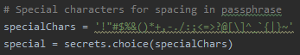

Previously there specialChars were one variable chosen when the program started but then the user had a redundant choice for each passphrase to be generated. Now the selecting special character choice is included in the functions loops, so each passphrase special is different.

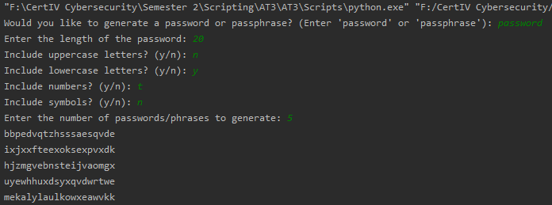

In the original version where we chose the character sets, there was a bug where the program didn’t check user inputs so if they make a typo instead of pressing y, the program generates passwords without the character set included.

To remedy this, I added error checking to each character set choice where if they select “y” the character set will be appended to the list, and selecting “n” will break the loop and move onto the next character set. I also changed the code that will end the program by requiring the user to input something before the exit(), this will make sure the user actually reads the message.

### Try Except ValueError:

When an integer was required to be inputted, if the user enters anything else, a Value Error would cause the program to crash.

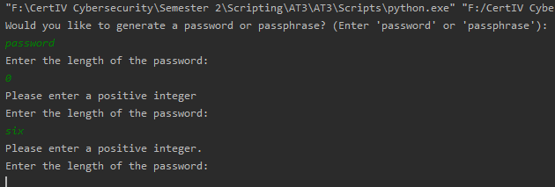

To remedy this I added error correction via two methods. I added a Try Except clause where it would try to added the input to the length variable unless a ValueError happened, which would prompt the user to input an integer then loop back. There was also another form of error correction where I made sure that the length variable must be greater than 0 as a password can’t be generated with 0 characters.